**HTML Favicon**

A favicon is a small image displayed next to the page title in the browser tab.

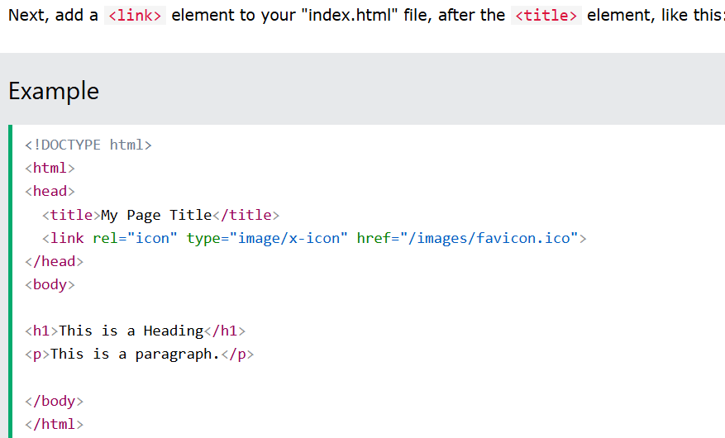

IN MY DESIGN

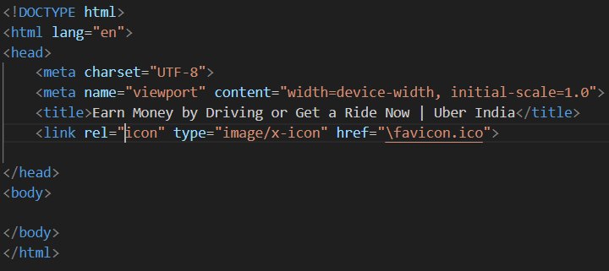

position: absolute;

    top: 23%;

    left: -27%;

    font-family: system-ui, "Helvetica Neue", Helvetica, Arial, sans-serif;

    font-size: 14px;

    font-weight: 500;

    text-align: center;

    background-color: #000000;

    color: #FFFFFF;

    text-decoration: none;

    line-height: 34px;

    margin-left: 24px;

    width: 57px;

    height: 33px;

*{

    margin: 0;

    padding: 0;

}

.body{

    margin: 0;

    padding: 0;

    height: 100%;

    max-width: fit-content;

}

.container{

    background-color: #FFFFFF;

    width: 100%;

    max-height: fit-content;

    margin: 0;

}

.header{

    /*display: flex;

    flex-direction: row;*/

    background: #000000;

    width: 100%;

    height: 64px;

    margin: 0;

    padding: 0;

}

.empty-div{

    width: 58px;

    height: 64px;

    background-color: #000000;

}

.content-div{

    width: 70px;

    height: 64px;

    background-color: #000000;

}

.uber-head{

    font-family: system-ui, "Helvetica Neue", Helvetica, Arial, sans-serif;

    font-size: 24px;

    text-align: center;

    color: #FFFFFF;

    text-decoration: none;

    line-height: 60px;

}

/*.head-subs{

    font-family: system-ui, "Helvetica Neue", Helvetica, Arial, sans-serif;

    font-size: 14px;

    font-weight: 500;

    text-align: center;

    background-color: #000000;

    color: #FFFFFF;

    text-decoration: none;

    line-height: 60px;

    margin-left: 12px;

}*/

.head-subs {

    display: inline-block;

    padding: 10px 20px;

    background-color: blue;

    color: white;

    text-decoration: none;

    border-radius: 5px;

}

.head-subs:hover {

    background-color: darkblue;

}